Please check the following

- on each PMs, please run "du -sh /usr/local/mariadb/columnstore/dataN, where N is the 1, 2, 3 for PM1, PM2, PM3 respectively.
PM1
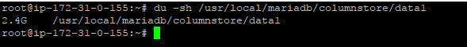
PM2
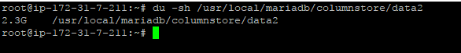
PM3
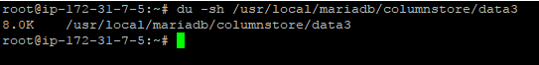
- on the mcsadmin console, run "redistributedata start"

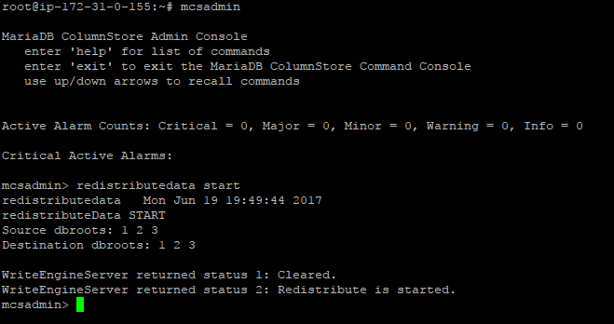

- while redistributedata is running, run "redistributedata status" a few times and capture output

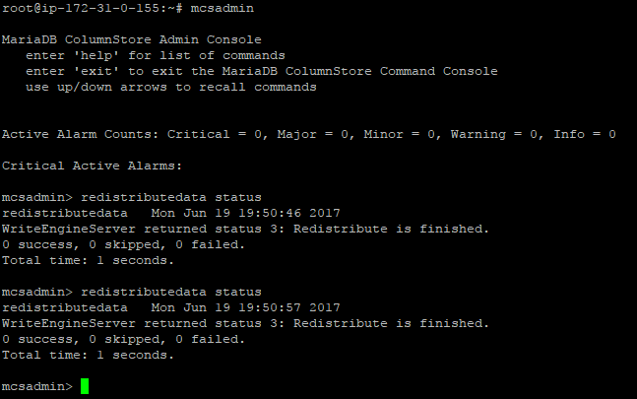
- when redistributedata is finished, check dbroot sizes again.
- I have waited till its completed but tell you its getting completed in one-two seconds only.
5) repeat step 1
- Check with repeating the steps but same result I got it.

