In Power Bi, Obtain data :
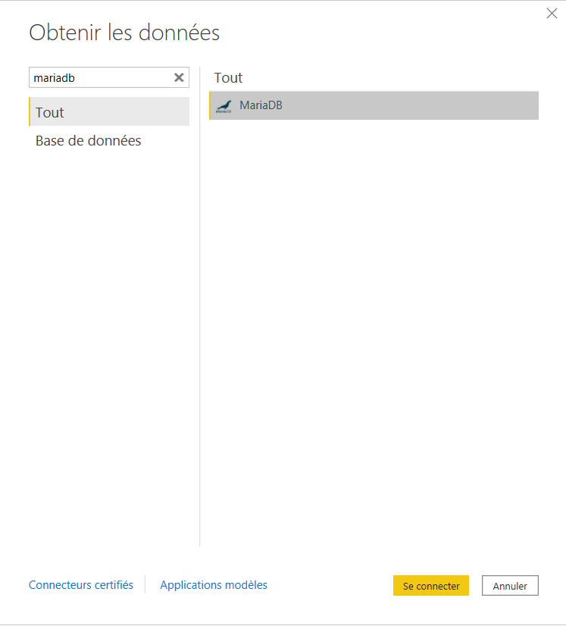

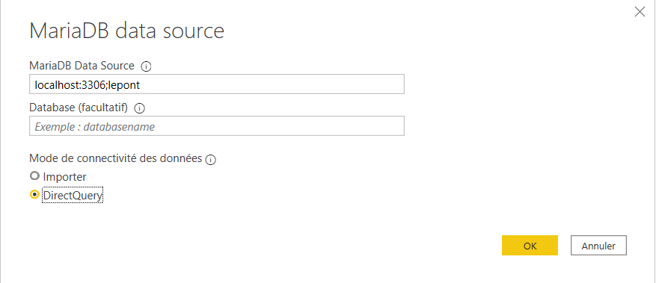

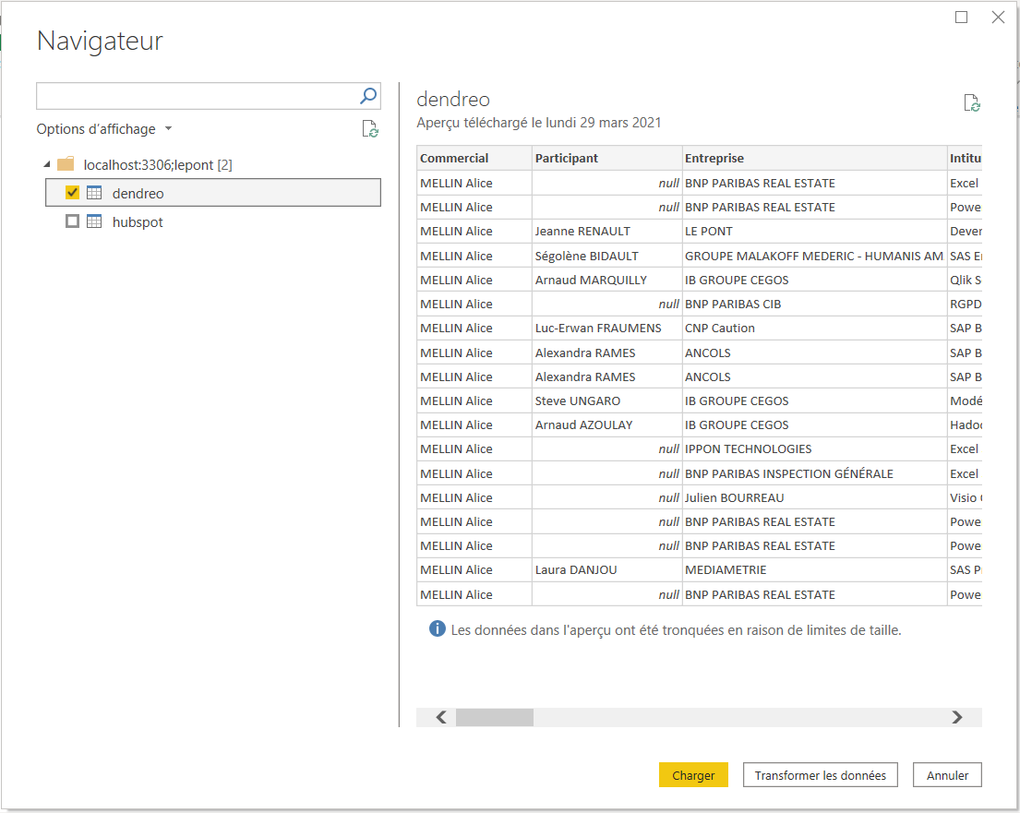
Transform Data

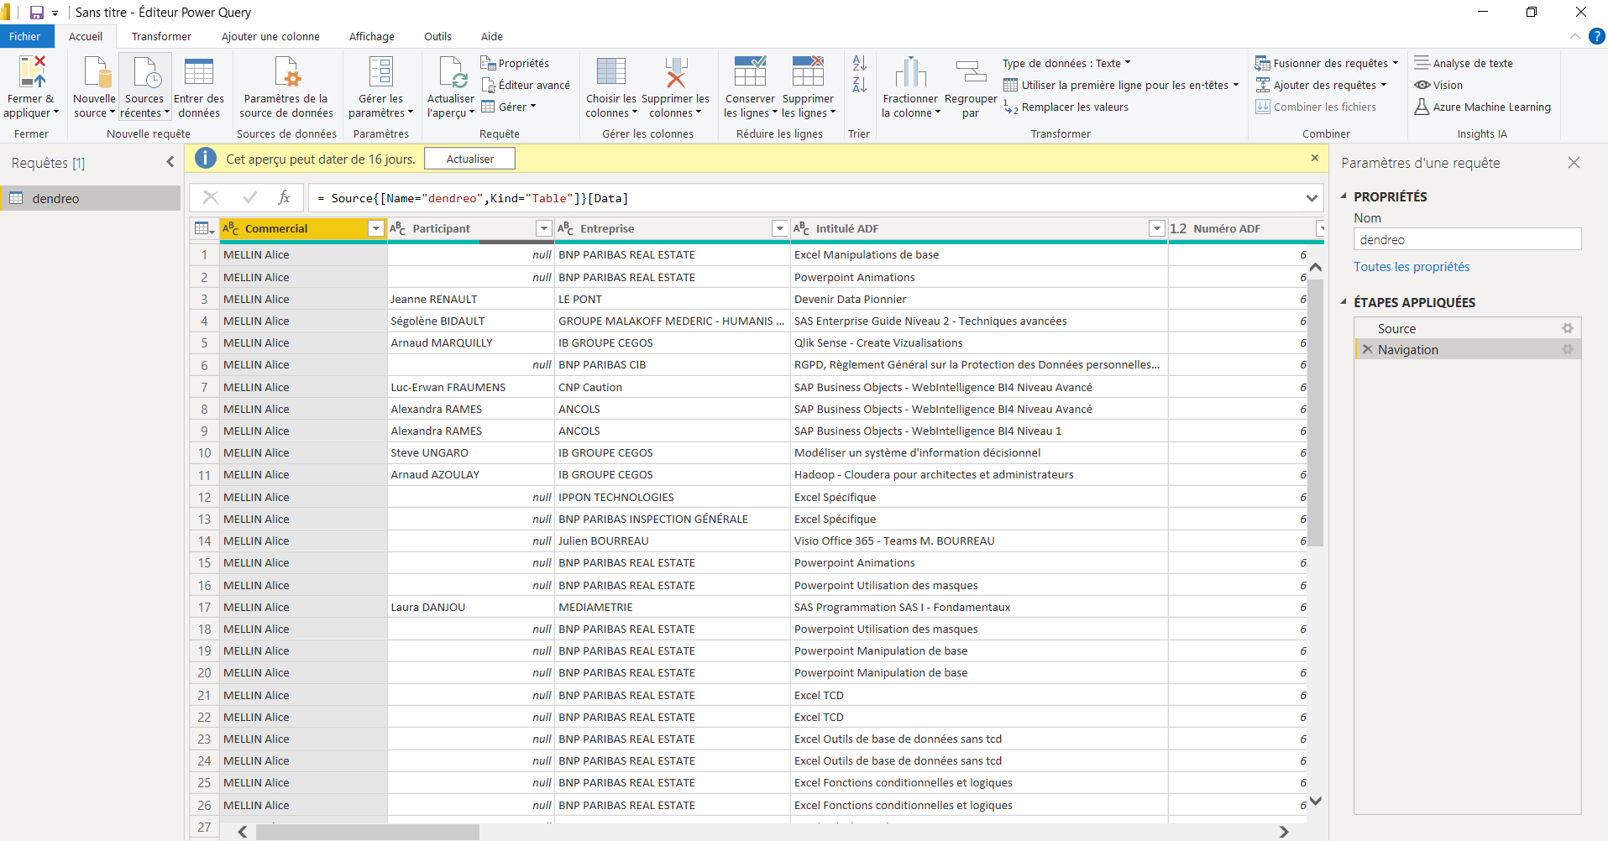
Close and Apply

In the report Builder, use a numeric column (here 2021Total) OK
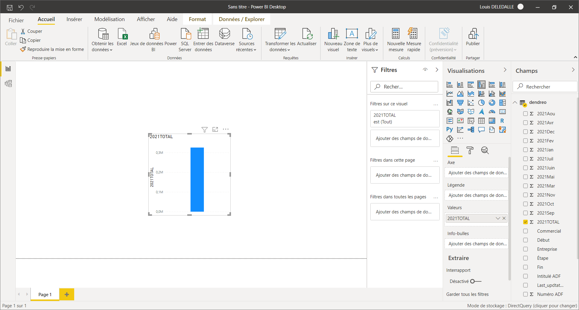

When I try to drop a character column (here Commercial), I get an error :
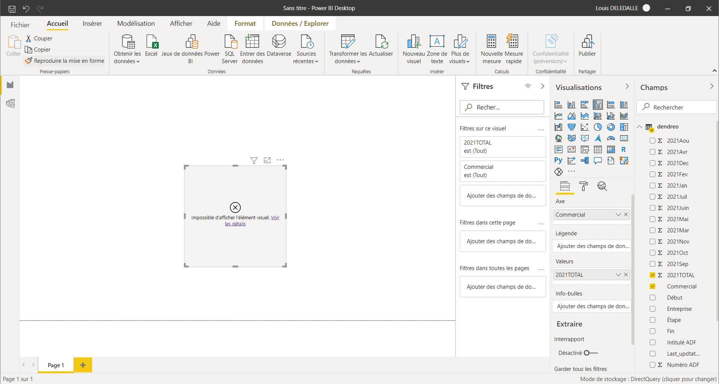

And if I click on Details :
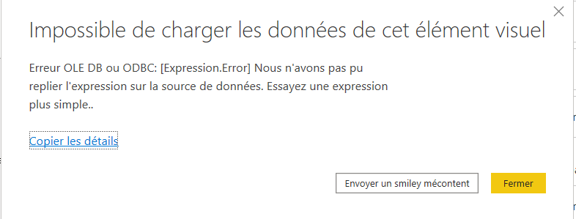
The english translation would be :
Impossible to load this visual item ?
OLE DB or ODBC error: [Expression.Error] We couldn't fold the expression to the data source.
If I copy Details :
Feedback Type:
Frown (Error)

Timestamp:
2021-04-13T12:55:42.0984956Z

Local Time:
2021-04-13T14:55:42.0984956+02:00

Session ID:
511178e6-1930-4fa8-970f-7525da2e996b

Release:
March 2021

Product Version:
2.91.884.0 (21.03) (x64)

Error Message:
Erreur OLE DB ou ODBC: [Expression.Error] Nous n'avons pas pu replier l'expression sur la source de données. Essayez une expression plus simple..

OS Version:
Microsoft Windows NT 10.0.19041.0 (x64 fr-FR)

CLR Version:
4.7 or later [Release Number = 528372]

Peak Virtual Memory:
38.3 GB

Private Memory:
612 MB

Peak Working Set:
853 MB

IE Version:
11.789.19041.0

User ID:
9f7f3992-141f-4480-a2d1-731d945e7edb

Workbook Package Info:
1* - fr-FR, Query Groups: 0, fastCombine: Disabled, runBackgroundAnalysis: True.

Telemetry Enabled:
True

Snapshot Trace Logs:
C:\Users\louis\Microsoft\Power BI Desktop Store App\FrownSnapShot78fc9297-fac0-4e50-926a-21044070c990.zip

Model Default Mode:
DirectQuery

Model Version:
PowerBI_V3

Performance Trace Logs:
C:\Users\louis\Microsoft\Power BI Desktop Store App\PerformanceTraces.zip

Enabled Preview Features:
PBI_shapeMapVisualEnabled
PBI_SpanishLinguisticsEnabled
PBI_JsonTableInference
PBI_NewWebTableInference
PBI_ImportTextByExample
PBI_ExcelTableInference
PBI_qnaLiveConnect
PBI_eimInformationProtectionForDesktop
PBI_azureMapVisual
PBI_dataPointLassoSelect
PBI_compositeModelsOverAS
PBI_narrativeTextBox
PBI_dynamicParameters
PBI_anomalyDetection

Disabled Preview Features:
PBI_newFieldList
PBI_cartesianMultiplesAuthoring

Disabled DirectQuery Options:
TreatHanaAsRelationalSource

Cloud:
GlobalCloud

DPI Scale:
125%

Supported Services:
Power BI

Formulas:

section Section1;

shared dendreo = let
Source = MariaDB.Contents("localhost:3306;lepont", null),
dendreo_Table = Source{[Name="dendreo",Kind="Table"]}[Data]
in
dendreo_Table;

